INFO1113 Tanks Assignment

**Overview**

This report will cover in detail the implementation of the Tanks game that is implemented in the Java programming language. It will in detail the implementation and the classes that are used to implement this game.

In this version of the Tanks game, 4 players in the form of tanks takes turns firing projectile at each other. The objective of this game is to take out the opponents tank to advance to the next level.

**UML Diagram**

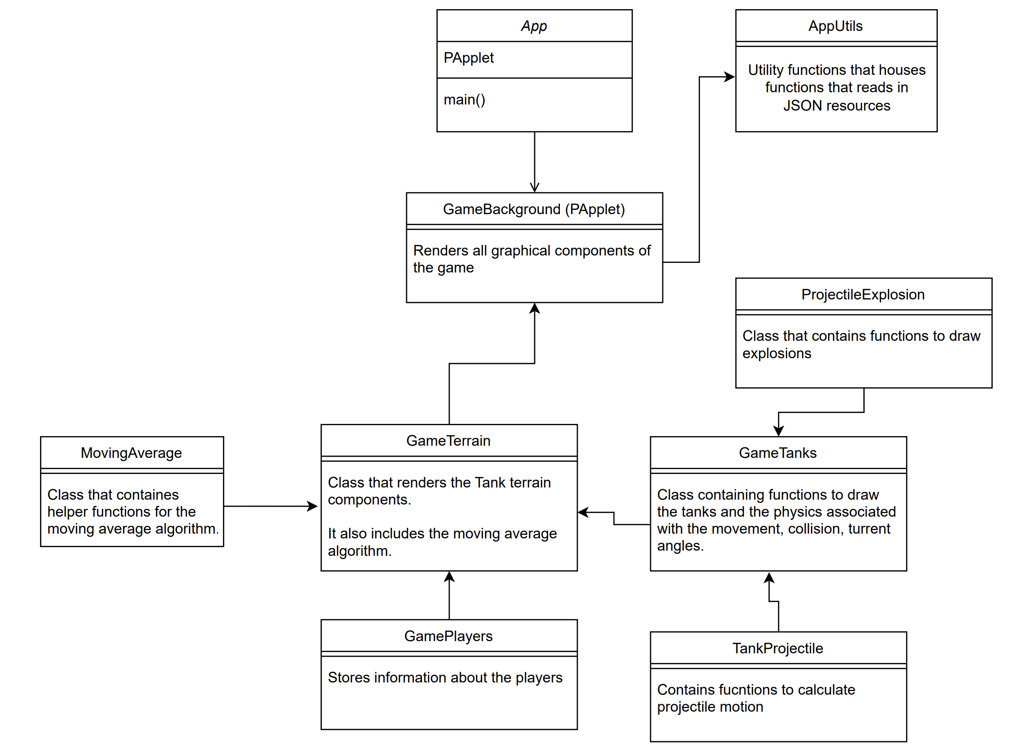

**Implementation Decisions**

When developing this application, a crucial design decision is to split the application into its functional components and can be inherited from a master class which in this case it’s GameBackground class. GameBackground class acts as a central class in which all other functionality of the game will extend to.

The main components of the game that this implementation has broken down to:

1. **TankProjectile**

• Methods for getting and setting projectile properties, updating position, and drawing projectiles.

2. **MovingAverage**

• Class that contains helper functions for the moving average algorithm.

3. **ProjectileExplosion**

• Methods for setting and getting explosion details and drawing explosion

4. **GameTerrain**

• Methods for drawing terrain and environmental features and setting game players

5. **GamePlayer**

• Methods for managing player details and their tanks

6. **AppUtils**

• Static utility methods for reading configuration and player colours

7. **GameBackground** (inherits from PApplet)

• Various methods for game setup and interactions like key presses and wind generation

8. **GameTank**

* Methods for managing tank properties, movement, and interaction with terrain including creating tank turrets, drawing blasts.